Instrumental Music Program

c/o UC High School Kaleen
Baldwin Drive
Kaleen ACT 2617

Ph (02) 6142 0477
e-mail: imp@imp.act.edu.au
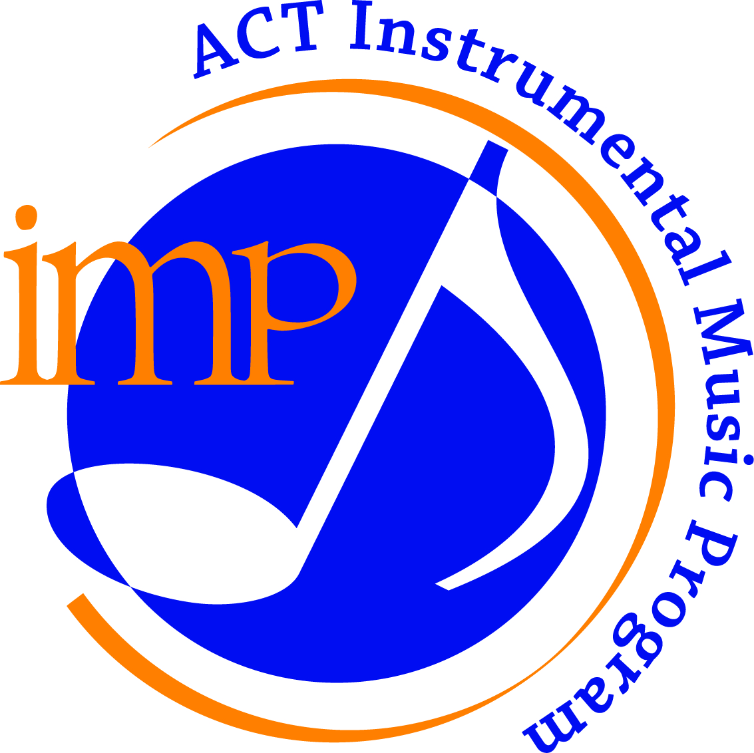

Excellence in Instrumental Music Education since 1973

Information for Parents of Year 4 students

The Instrumental Music Program (IMP) is a Section of the Education Directorate that provides to your Primary School a package of services designed to supplement the music education of up to 23 selected children in both Year 5 and Year 6. The IMP has been operating in the ACT for over 50 years and is unique to Canberra. It has also attracted a great deal of national and international interest because of its methods, organisation, and achievements.

A selection process has already begun with each Year 4 classroom teacher providing information to the Program on several attributes that are important to beginning music students. This selection process was reviewed in 2019 by Dr Anita Collins and the recommendations from this review have been incorporated into the current process. At the beginning of Year 5 the IMP will work with staff at your school to administer a music perception survey. Your child will be asked to answer some questions about music that is played to them. This is designed to determine each child’s ability to hear differences in the sounds of notes, melodies and rhythms and is merely another aspect of the selection process. When all of the criteria are assembled, the IMP will provide a list of students to the Principal of your school. The Principal, in conjunction with the classroom teachers, will finalise the list of students to whom offers will be made for Band Class membership. Please note that places will be offered first to students not already having private lessons on a band instrument. More advanced students will be welcome to be a part of the School Band but will not be a part of the IMP Band Class.

Instruments in IMP Band Classes include oboe, flutes, clarinets and percussion in woodwind schools; trumpets, trombones, euphoniums, tubas and percussion in brass schools. Group lessons will be given, and no child will be required to take private lessons. Directorate teachers employed and attached to the IMP for their special instrumental teaching and classroom skills, will visit your school for lessons twice a week.

Students are provided with an instrument (along with its maintenance and repairs of accidental damage) and all the music required for their tuition. There will be a cost to families of students involved in the program and this cost is set by each individual school. Please contact your school to find out the amount you will be required to contribute. This cost is a contribution to the hire of the instrument, service and maintenance of the instrument and specialist tuition as well as print music. This cost is not reflective of the total cost of the program, or resources supplied.

Membership of the IMP Band Class is not compulsory and when offers of membership are made to the selected students, they may choose to decline the offer. There is a maximum number of 23 places available in each IMP Band Class depending on the size of the cohort.

We hope this information clarifies any questions you may have about the IMP and its selection process. You can find further information on our website.

Joel Copeland

Principal
ACT Instrumental Music Program

