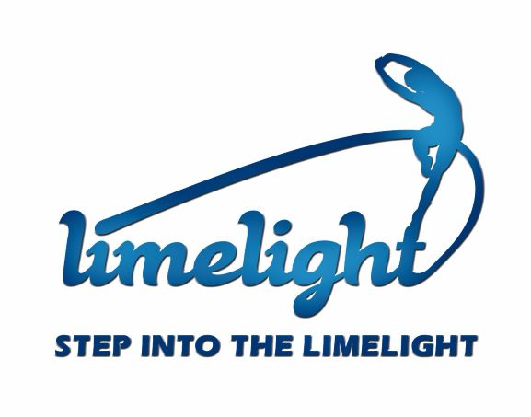
Step into the Limelight 2024
Your school could be involved in:
Program | Information
STEP INTO THE LIMELIGHT GALA PROGRAMS
Massed Primary Choir | For students in year 3 to 6. All musical resources supplied. Teacher induction session: Friday 21 June (week 8, term 2)
Massed Primary Dance Group | For students in year 4 to 6. All choreography resources. Teacher induction session: Friday 28 June (week 9 term 2)
Short Featured Films | Open to all students. Selected films will be screened during the Gala performances.
Featured Artist’s Vocal Ensemble | For students’ years 9 to 12. Auditioned group of senior performers. Video audition required
Featured Schools Performance Groups | Open to all schools. An auditioned item – dance, drama, music created, costumed and refined by the school for presentation at the Gala.
Featured Solo Item – Instrumental music, dance, drama | Open to all schools. High level of expertise required for item to be considered. Audition required.
Backstage Crew Team | Open to students 15 years and above. Be involved in everything that it takes to run the show behind the scenes. Teacher reference required.
STEP INTO THE LIMELIGHT ART EXHBITION
Artwork call out for print and digital advertising | Open to all schools and students. Images of artworks to be used for exhibition promotion. Submit images to Limelight@ed.act.edu.au by Friday 24 May (week 4 term 2)
Artwork Registration for Exhibition | Open to all students. Artworks from each school which document the very best of what students can achieve. No greater than A1 wall space total for all submitted works. Artworks due by Friday 21 June (week 8 term 2).  Isabel Matthews Scholarship announced. Exhibition is held at M16 Artspace

