Instrumental Music Program

c/o UC High School Kaleen
Baldwin Drive
Kaleen ACT 2617

Ph (02) 6142 0477
e-mail:imp@imp.act.edu.au
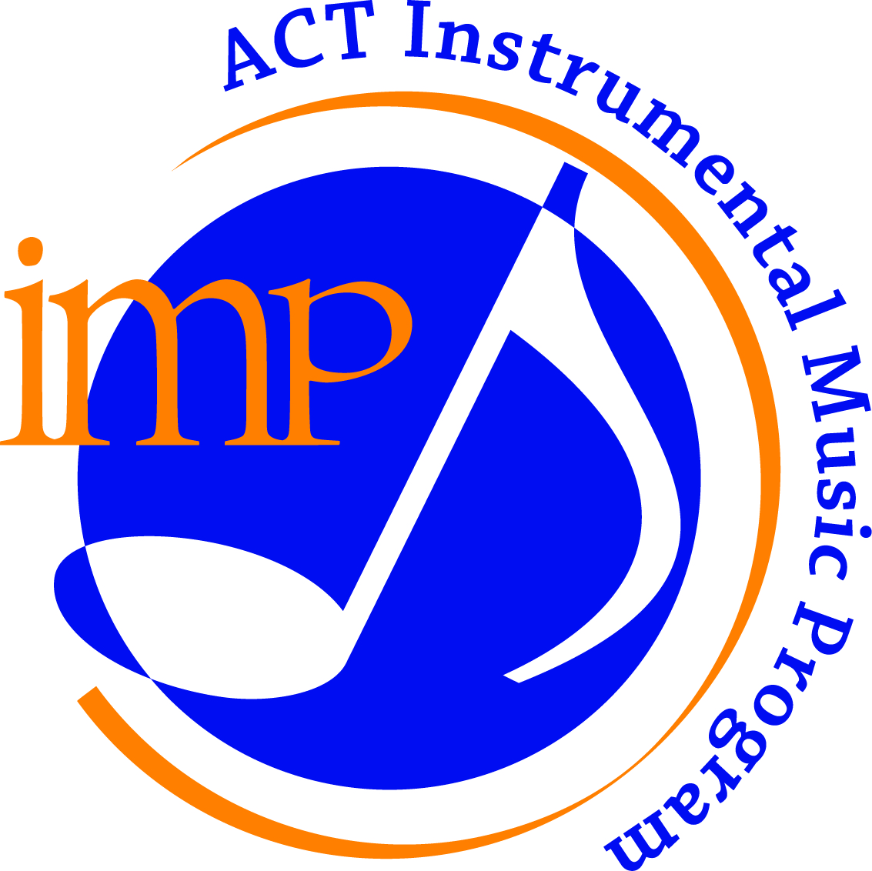

Excellence in Instrumental Music Education since 1973

Agreement for loan of Musical Instrument

I of
Name Address
parent/guardian of
Student’s name
hereinafter called 'the borrower', hereby acknowledge that I have received on loan from

………………………………………………………………………………………………………………………
Student’s school

the following stores, the property of the ACT Education Directorate, namely:
ITEM and BARCODE VALUE $

and to be used subject to the following conditions:

1. The musical instrument shall be returned to ……………………………………………………..school
by 3 p.m on …………………………… 20 ……..…
2. The musical instrument shall be maintained in good order and condition at the expense of the borrower at all times during the period of the loan.
3. The borrower shall not modify or alter the musical instrument in any manner.
4. The borrower shall return the musical instrument in good order and condition and shall indemnify the Directorate against any loss or damage to the stores during the period of the loan.
5. The borrower shall not assign, mortgage, lend, pledge or part with possession of the said musical instrument.
6. The borrower accepts liability for any accident that may arise from use of the said equipment during the period of the loan and shall indemnify the Directorate, its officers, servants and agents against all actions, proceedings or demands in respect of any loss or injury arising out of, or in connection with the use of the said musical instrument during the period of the loan.
7. The borrower shall permit any duly authorised officer of the Directorate to have access to the musical instrument at any reasonable time to inspect the state and condition thereof

Dated this day of 20

Signature of borrower or authorised Stores Holding Officer
Representative ACT Education Directorate

